Program of Activities

For the 2018 Spring Meeting of the

**Mathematical Association of America**

**Ohio Section**



Spring, 2018

Miami University

Oxford, Ohio

April 6 – 7, 2018

**Mathematical Association of America**

**Ohio Section**

MAA Ohio Section

**Spring 2018 Program**

**Friday, April 6**

|  |  |  |
| --- | --- | --- |
| **Time** | **Event** | **Location\*** |
| 12:00-4:00 | Registration | 115 |
| 12:00-1:20 | Leo Schneider Student Team Competition | 201, 219 |
| 12:00-1:00 | Committee Meetings: |  |
|  | CONCUR (Curriculum) | 118 |
|  | CONSACT (Section Activities) | 110 |
|  | CONTEAL (Teacher Education & Licensure) | 112 |
| 1:00-4:00 | Vendor & Book Exhibits | 120 |
| 1:30-1:45 | Welcome and Announcements | 101 |
| 1:45-2:45 | Invited Address: **“**Women and Mathematics in the Time of Euler**”** Elizabeth Mayfield | 101 |
| 2:45-3:00 | Break |  |
| 3:00-4:00 | Invited Address: **“**The Power of the Karush-Kuhn-Tucker Theorem and an Introduction to the Optimization Theory**”** Olga Brezhneva | 101 |
| 4:10-5:50 | Executive Committee Meeting | 118 |
| 4:30-6:10 | Contributed Paper Sessions | 110, 112, 114 |
| 6:10-7:00 | Social Time |  |
| 7:00-8:00 | Student Pizza Party | Courtyard |
| 7:00-8:00 | Banquet | Pavilion A Armstrong Center |
| 8:00-9:00 | Invited Address: “Bingo Paradoxes” Arthur Benjamin | 101 |
| 9:00 | Business Meeting and Presentation of Teaching Award | 101 |

*All events except the banquet are in Bachelor Hall

**Saturday, April 7**

All events are in Bachelor Hall

|  |  |  |
| --- | --- | --- |
| **Time** | **Event** | **Location** |
| 8:00-10:00 | Registration | 115 |
| 8:00-10:00 | Book Vendors and Exhibits | 120 |
| 8:00-8:50 | Coffee and Pastries | 115 |
| 8:15-8:50 | Committee On Local Arrangements | 112 |
| 8:15-8:50 | Executive Committee Meeting (if needed) | 114 |
| 9:00-9:10 | Welcome and Announcements; Student Competition Results | 101 |
| 9:10-10:10 | Invited Address:  “Gerbert d’Aurillac and the March of Spain: A Guy in the Right Place at the Right Time”  Elizabeth Mayfield | 101 |
| 10:10-10:30 | Break |  |
| 10:30-11:45 | Contributed Paper Session | 112, 114 |
| 11:45-12:00 | Break |  |
| 12:00-1:00 | Invited Address:  **“**When One Door Opens, Another Closes**”**  Chris Swanson | 101 |
| 1:00-1:10 | Closing Remarks | 101 |

**Abstracts of Invited Addresses**

**Friday**

**Speaker:** Betty Mayfield, Hood College

**Title:** *Women and Mathematics in the Time of Euler*

**Abstract:** This talk examines some female contemporaries of Euler, some famous, some not so famous. We will look at mathematics that was written both by and for women in the eighteenth century.

**Speaker:** Olga Brezhneva, Miami University

**Title:** The Power of the Karush-Kuhn-Tucker Theorem and an Introduction to the Optimization Theory   
   
**Abstract:** We begin the talk by introducing some optimization problems. Then we turn our attention to optimality conditions and the Karush-Kuhn-Tucker (KKT) Theorem, which is one of the powerful results in the theory of optimization. We will discuss some history of the KKT theorem and illustrate how only basic facts from linear algebra and the definition of differentiability can be used to prove the theorem. We will also talk about some current trends in the area of optimization and optimality conditions, specifically. This talk will be accessible to undergraduate students.

**Speaker:** Arthur Benjamin, Harvey Mudd College

**Title:** Bingo Paradoxes

**Abstract:** Imagine you are walking past a crowded Bingo parlor with hundreds of people playing. Suddenly you hear one person excitedly call out "Bingo!". Is it more likely that they have 5 in a row or 5 in a column (or are they the same)? Or is the most probable outcome diagonal? The answers will surprise you.

**Saturday**

**Speaker:** Betty Mayfield, Hood College

**Title:** *Gerbert d’Aurillac and the March of Spain: A Guy in the Right Place at the Right Time*

**Abstract:** Gerbert was a tenth century scholar and churchman who eventually was named Pope Sylvester II. In the Year 1000, he probably knew more mathematics than anyone else in Europe. We'll explore how that came to be, and we will look at some of his mathematical writing.

**Speaker:** Chris Swanson, Ashland University

**Title:** When One Door Opens, Another Closes

**Abstract:** A form of entertainment that has greatly grown in popularity in the last few years is the escape room. In an escape room, participants typically pay $20-$30 each to be locked in a room for 45-60 minutes during which they try to find clues and solve puzzles to figure out how to escape before time expires. While I have not participated in an escape room (at least as of when this abstract was due), I have great interest in doing so and was curious if there was an app available that would simulate an escape room. In searching, I found the app “100 Doors Challenge” and discovered that mathematics was helpful in opening doors on some of the levels. I will present how to use mathematics to open the door on some levels of this app in order to move on to the next closed door.

**Brief Biographies of Invited Speakers**

**Betty Mayfield, Hood College**

Betty Mayfield is Professor Emerita of Mathematics at Hood College in Frederick, Maryland. Her dissertation at the University of Rhode Island focused on partial differential equations, especially those describing the propagation of sound underwater. But soon after she began teaching, she discovered a love of the history of mathematics and has devoted herself to learning more about it for most of her career. As past Chair of the MAA’s Committee on Sections, she describes herself as the world’s greatest fan of MAA Sections, spreading the word about their energy and good work and sense of community. She has also served as Chair of the Committee on Undergraduate Student Activities and Chapters and First Vice President of the MAA. She is attending our Section meeting as an MAA Section Visitor and is eager to participate in many of the meeting’s activities and learn more about the Ohio Section and its members.

**Olga Brezhneva, Miami University**

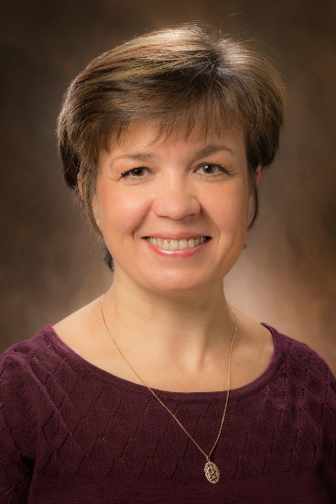**Olga Brezhneva** is an Associate Professor of Mathematics and an Affiliate of the Department of Electrical and Computer Engineering at Miami University. She received her M.S. degree in Applied Mathematics from Moscow State University and her Ph.D. in Mathematics from the Russian Academy of Sciences. Prior to coming to Miami University in 2004, Olga completed postdoctoral work at the Institute for Mathematics and its Applications at the University of Minnesota. She received the E. Phillips Knox Distinguished Teaching Award at Miami University in 2007 and a Greater Cincinnati Consortium of Colleges and Universities Teaching Award in 2008. Her primary area of research is optimization and she is a co-author of 41 publications in the areas of optimization, differential equations, and numerical analysis.

**Arthur Benjamin, Harvey Mudd College**

****Born and raised near Cleveland (Mayfield Heights, Ohio) **Arthur Benjamin** earned his B.S. in Applied Mathematics from Carnegie Mellon U and his PhD in Mathematical Sciences from Johns Hopkins University. Since 1989, he has taught at Harvey Mudd College, where he is the Smallwood Family Professor of Mathematics. He has served as co-Editor (with Jennifer Quinn) of Math Horizons for MAA, he is a Fellow of the AMS, and has received numerous awards, including the MAA Haimo Prize for distinguished teaching. the MAA Beckenbach Book prize for Proofs That Really Count, the Communications Award from the Joint Policy Board for Mathematics. He has given 3 TED Talks, which have been viewed over 12 million times. His newest book, a New York Times Bestseller in Education, is called The Magic of Math: Solving for X and Figuring out Why.  Aside from his research interests in combinatorics and game theory, he enjoys tournament backgammon, writing parodies, racing calculators, and performing magic.

**Chris Swanson, Ashland University**

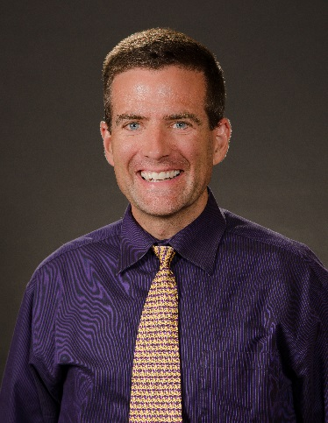**Christopher N. Swanson** is a native Ohioan (but don’t call him a Buckeye) who is originally from the Massillon/Canton area and received his B.S. from Denison University in 1994. He received his Ph.D. from the University of Michigan (GO BLUE!) in 1999 under the direction of Thomas F. Storer and immediately joined the faculty at Ashland University where he has also been the Director of the university-wide Honors Program for the last 11 years. Chris’s research interests are combinatorics and probability. Chris is a national Project NExT Fellow (Brown Dot) and is the faculty advisor for the AU Problem Solving Group. Chris has been active in the Ohio Section, having been an Ohio NExT Fellow, having served on CONCUR, CONSTUM and the Ohio NExT Organizing Committee, having chaired contributed paper sessions, and having given 20 presentations at Ohio Section meetings or Ohio NExT workshops. In 2006, Chris received the national Alder Award from the MAA in recognition for distinguished teaching by a beginning mathematics faculty member and he received the Ohio Section Distinguished Teaching Award in 2014. In his spare time, Chris enjoys watching movies, playing disc golf, cycling and participating in the applied probability seminar.

**Contributed Paper Sessions**

*denotes undergraduate student

**Friday, April 6**

**4:30—6:05**

**Session A of Friday Sessions A, B and C**

**Bachelor Hall 110**

|  |  |
| --- | --- |
| Time | **Session A** 110  Session Chair:  Kyle Calderhead, Malone University |
| 4:30 – 4:45 | ***The Galois Correspondence of Covering Spaces***  Vladimir P. Sworski*  Cleveland State University  Abstract 1 |
| 4:50 – 5:05 | ***Optimizing Congressional Voting Districts using a Genetic Algorithm***  Kathleen Buch*  Xavier University  Abstract 4 |
| 5:10 – 5:25 | ***An Application of Groebner Bases to Robotics***  Lynn Drotos*  Cleveland State University  Abstract 7 |
| 5:30 – 5:45 | ***Passive Scalar Transport of Contaminants Via Travelling Waves***  Ian M. Simpson*  Ohio Northern University  Abstract 10 |
| 5:50 – 6:05 | ***Matrix Representations of Hypercomplex Numbers***  Kenneth C. Howe*  Sinclair Community College  Abstract 13 |

**Contributed Paper Sessions**

**Friday, April 6**

**4:30—6:05**

**Session B of Friday Sessions A, B and C**

**Bachelor Hall 112**

|  |  |
| --- | --- |
| Time | **Session B** 112  Session Chair:  M. B. Rao  University of Cincinnati |
| 4:30 – 4:45 | ***Riveting Statistics of 2017***  M. B. Rao  University of Cincinnati  Abstract 2 |
| 4:50 – 5:05 | ***Kirkman’s Schoolgirl Problem: A Suboptimal Solution for Arbitrary Parameters***  Harrison Potter  Marietta College  Abstract 5 |
| 5:10 – 5:25 | ***A Mistake on the 2017 Leo Schneider Student Team Competition***  Laurence D. Robinson  Ohio Northern University  Abstract 8 |
| 5:30 – 5:45 | ***Nonhomogeneous Risk Rank Analysis Method for Security Network System***  Pubudu K. Hitigala Kaluarachchilage  Miami University – Middletown  Abstract 11 |
| 5:50 – 6:05 | ***Analysis of Pharmaceutical Manufacturing Data with a Logistic Regression Model***  Kimberly A. Schveder  Cleveland State University  Abstract 14 |

**Contributed Paper Sessions**

**Friday, April 6**

**4:30—6:05**

**Session C of Friday Sessions A, B and C**

**Bachelor Hall 114**

|  |  |
| --- | --- |
| Time | **Session C** 114  Session Chair:  Giorgi Shonia  Ohio University – Lancaster |
| 4:30 – 4:45 | ***Abstract Altruism***  Rosemarie C. Emanuele  Ursuline College  Abstract 3 |
| 4:50 – 5:05 | ***Combating High Textbook Costs with a Statewide Open Educational Resource Initiative***  Anna Davis  Ohio Dominican University  Abstract 6 |
| 5:10 – 5:25 | ***Using Sage Math for classroom assessment***  Giorgi Shonia  Ohio University – Lancaster  Abstract 9 |
| 5:30 – 5:45 | ***Leveraging Art to Teach Mathematics***  David Meel  Bowling Green State University – Main  Abstract 12 |
| 5:50 – 6:05 | ***Lesson Planning from Cartoons***  Elizabeth Haynes  Wilmington College  Abstract 15 |

**Contributed Paper Sessions**

**Saturday, April 7**

**10:30—11:45**

*denotes undergraduate student

**Session D of Saturday Sessions D and E**

**Bachelor Hall 112**

|  |  |
| --- | --- |
| Time | **Session D**  112  Session Chair:  Clayton Brooks  Marshall University |
| 10:30– 10:55 | ***Brownian Motion and the Cantor Set***  Yuanzhe Liu*  Oberlin College  Abstract 16 |
| 10:50– 11:05 | ***Stochastically Generated Jazz***  Kennetta Palmore*  Cleveland State University  Abstract 18 |
| 11:10– 11:25 | ***Improving in Professional Golf***  Michael Woode*  Ashland University  Abstract 20 |
| 11:30– 11:45 | ***Expanding the One-Sided Infinite Ladder***  Kyle R. Puhl*  Ashland University  Abstract 22 |

**Contributed Paper Sessions**

*denotes undergraduate student

**Saturday, April 7**

**10:30—11:45**

**Session E of Saturday Sessions D and E**

**Bachelor Hall 114**

|  |  |
| --- | --- |
| Time | **Session E**  114  Session Chair:  Ian Hogan  Central State University |
| 10:30– 10:55 | ***Sports Analytics & Undergraduate Research***  Drew Pasteur  College of Wooster  Abstract 17 |
| 10:50– 11:05 | ***Lessons Learned from Teaching Online***  Katie Cerrone  The University of Akron  Abstract 19 |
| 11:10– 11:25 | ***How hard is it to triangulate a torus?***  Preston Nichols  Shawnee State University  Abstract 21 |
| 11:30– 11:45 | ***Exploring the Asymptotic Behavior of a Stochastic Process with Simulation and Visualization***  Barbara Margolius  Cleveland State University  Abstract 23 |

**Abstracts of Contributed Papers**

**Friday 4:30-4:45**

***The Galois Correspondence of Covering Spaces***

Vladimir P. Sworski*

Cleveland State University

**Abstract 1:** Topological spaces are one of the fundamental building blocks of mathematics. They have a strong relationship with other mathematical objects such as groups and fields. A covering space of a specific topological space is mapped via a covering map so that all points in the original space are evenly covered by that mapping. Topological spaces have many covering spaces, and categorization of such spaces represented an interesting challenge to 20th century mathematicians.  The solution yields a Galois correspondence, which is a relationship between the various covering spaces of a given space on the one hand, and the subgroups of its fundamental group on the other.

***Riveting Statistics of 2017***

M. B. Rao

University of Cincinnati

**Abstract 2:** The Royal Statistical Society invited entries from the public a fascinating piece of statistic. Some winners are announced. I will review some of these winners. I will demonstrate that some of these statistics are not at all surprising!

***Abstract Altruism***

Rosemarie C. Emanuele

Ursuline College

**Abstract 3:** The study of the philanthropic sector reveals interactions that mimic “markets” where buyers and sellers (or donors and recipients,) are brought together in transactions that resemble the iconic “supply” and “demand” curves of traditional Economics. However, here “prices” are often not visible, as these encounters often operate on vague notions of “altruism” or a “warm glow,” making changes in these markets difficult to study empirically.    
  
When a market in the philanthropic sector is examined along with companion markets for substitute and complementary goods or services, this set of three related markets can be identified as a mathematical “group.” Examining the possible outcomes from the interactions of such markets reveals that there is a limited number of directions in which quantity and price can move together as a result changes in these three interrelated markets. While the “price” bringing buyers and sellers together sometimes cannot be observed directly, knowledge of the direction in which outcomes in related markets are changing can lead to insight as to what is happening in markets that cannot be directly observed. Thus, group theory may help solve a statistical difficulty that haunts economists studying the nonprofit sector.

**Friday 4:50-5:05**

***Optimizing Congressional Voting Districts using a Genetic Algorithm***

Kathleen Buch*

Xavier University

**Abstract 4:** We examine the existence of bias in the congressional redistricting process within Ohio by creating an overall nonpartisan score for each district. The score is the sum of a weighted function with the parameters, based on the Ohio Legislature’s redistricting competition in 2009; compactness, population equality, fairness, and competitiveness. Although measuring compactness and population equality may be straightforward, defining fairness and competitiveness can become convoluted and subjective. Our fairness component is calculated using the efficiency gap method originally developed by Nicholas Stephanopoulos and Eric McGhee. We score competitiveness using an equation based on the percentage of votes won by a single political party. The weighted nature of our function is subject to change given the user and what parameters they wish to give more importance. We then utilize a genetic algorithm to optimize the score of districts. The algorithm provides a method by which to improve upon the score of each district by altering district lines and recalculating. This process allows for users to see how districts could be altered with a preference on certain district characteristics.

***Kirkman’s Schoolgirl Problem: A Suboptimal Solution for Arbitrary Parameters***

Harrison Potter

Marietta College

**Abstract 5:** At a team-building retreat you must assign the N attendees into teams of size n, with teams of size (n-1) only as needed.  When the activity changes, teams are reassigned so that attendees work with exclusively new teammates.  How many activities can you accommodate?  
  
Kirkman’s Schoolgirl Problem is N=15, n=3, with answer 7.  I present an algorithm, motivated by affine geometry and implemented in Excel, that generates suboptimal team assignments for any N and n.

***Combating High Textbook Costs with a Statewide Open Educational Resource Initiative***

Anna Davis

Ohio Dominican University

**Abstract 6:** North Central State College, in partnership with Ohio State University, Ohio Dominican University (ODU), OhioLINK and OACC was awarded a $1.3 million ODHE grant to evaluate, develop and curate Open Educational Resources (OERs) for twenty two courses, including several mathematics courses.  ODU was charged with leading the development of three upper-level mathematics courses.  In this presentation we will discuss the negative impact of high textbook costs, highlight the efforts of the grant team, and share the work led by ODU to develop a Linear Algebra OER.

**Friday 5:10-5:25**

***An Application of Groebner Bases to Robotics***

Lynn Drotos*

Cleveland State University

**Abstract 7:** This talk will discuss how Groebner bases can be used to make finding the positions of moving parts more simple. By creating simulations of robots of varying complexity, I will show that Groebner bases can be helpful, but they can become complicated very quickly.

***A Mistake on the 2017 Leo Schneider Student Team Competition***

Laurence D. Robinson

Ohio Northern University

**Abstract 8:** There was a mistake on the 2017 Leo Schneider Student Team Competition (won by the team from Ohio Northern University, I seem to recall).  In this talk I will discuss this mistake from a statistician's perspective.

***Using Sage Math for classroom assessment***

Giorgi Shonia

Ohio University – Lancaster

**Abstract 9**: Writing tests can be time consuming, especially with year-to-year modifications and different drafts. This talk shares some experience on streamlining this process using SageMath, producing randomization and visuals.

**Friday 5:30-5:45**

***Passive Scalar Transport of Contaminants Via Travelling Waves***

Ian M. Simpson*

Ohio Northern University

**Abstract 10**: In this paper we examine passive scalar transportation of contaminants via traveling waves. We utilize a system of partial differential equations to describe the motion and behavior of the ambient fluid and the contaminant. To model the behavior of the contaminant we use the advection diffusion equation. Since the contaminant has no dynamical effect on the ambient fluid, we examine how the contaminant will behave traveling with the ambient fluid.

***Nonhomogeneous Risk Rank Analysis Method for Security Network System***

Pubudu K. Hitigala Kaluarachchilage

Miami University – Middletown

**Abstract 11:** Network systems could have numerous vulnerabilities. We understand the process of generating vulnerabilities is highly stochastic and outcomes are hard to predict. Similarly, the behavior of attacks and attackers also have higher level unpredictability. When considering a particular system based on the discovered vulnerabilities the analysis must consider the dynamic nature of the effect of vulnerabilities over time. As we observed in our previous researches, effect of the vulnerabilities vary with the time over their life cycle. Therefore, for a particular system, the most threatening vulnerability at time t1 might not be the same at time t2. Hence, it would be very useful to have analytical models to observe the behavior of the rank of vulnerabilities based on the magnitude of the threat with respect to time for a given network system. Such ranking distribution over time would empower the defenders by giving the priority directions to attend on fixing vulnerabilities.

***Leveraging Art to Teach Mathematics***

David Meel

Bowling Green State University – Main

**Abstract 12:** In this talk, I will discuss how two different art based activities drew students into thinking about and exploring mathematical ideas.  In the first part of the talk, we will discuss how a particular composite photo drew students into discussing ideas related to calculus and in the second part, we will discuss how building a no-sew icosahedron quilt forced students into exploring a variety of mathematical ideas and insights.

**Friday 5:50-6:05**

***Matrix Representations of Hypercomplex Numbers***

Kenneth C. Howe*

Sinclair Community College

**Abstract 13:** Hypercomplex numbers are difficult to grasp intuitively because of their abstract nature. The use of matrix representations will hopefully make them easier to visualize and manipulate computationally. We will use MATLAB to demonstrate the use of matrices to represent hypercomplex numbers, as well as visualize some functions of such numbers.

***Analysis of Pharmaceutical Manufacturing Data with a Logistic Regression Model***

Kimberly A. Schveder

Cleveland State University

**Abstract 14:** In the case study about addressing the precipitation in a particular generic pharmaceutical drug, a logistic regression was used to model the probability of consumer complaints and the relevant explanatory variables. We examined the significance of each of the explanatory variables. Interactions were discovered between some of the explanatory variables and an association was discovered between two of the explanatory variables.

***Lesson Planning from Cartoons***

Elizabeth Haynes

Wilmington College

**Abstract 15:** Inspired by “Lines beyond y=mx+b” on <http://www.MathWithBadDrawings.com>, I created an assignment to teach graphing lines to a developmental math class.  Our MT099 is for students who have graduated high school (thus they have seen plenty of lessons about graphing lines before), but they scored a 16 or below on the math portion of the ACT.  I will show my assignment and discuss the (delightfully unexpected) results from class that day.

**Saturday 10:30-10:45**

***Brownian Motion and the Cantor Set***

Yuanzhe Liu*

Oberlin College

**Abstract 16:** The harmonic measure distribution function (h-function) measures the behavior of randomly moving Brownian particles inside two-dimensional domains. In this talk, we will discuss our simulation of Brownian motion and the resulting h-functions for a variety of domains with boundary. In particular, we will explore the h-function of the domain whose boundary is the Cantor set.

***Sports Analytics & Undergraduate Research***

Drew Pasteur

College of Wooster

**Abstract 17:** The interdisciplinary field of sports analytics is an excellent fit for undergraduates, particularly in light of the MAA's new Sports SIGMAA.  A brief history of sports analytics will be given, followed by a focus on current open questions.  The talk will conclude with tips for mentoring student researchers in this area, and examples of such projects.

**Saturday 10:50-11:05**

***Stochastically Generated Jazz***

Kennetta Palmore*

Cleveland State University

**Abstract 18:** I analyzed and attempted to create pleasing music through the use of stochastic matrices. I looked at the math behind the music, the probability of particular harmonies occurring, and the entropy of these musical processes. A melody was then produced and combined with the harmonies to produce a short piece of music in a major and a minor key. I then applied this method to jazz music and created a piece using this method (with slight changes).

***Lessons Learned from Teaching Online***

Katie Cerrone

The University of Akron

**Abstract 19:** Teaching math effectively in an online platform can be intimidating. As many students will tell you, taking a math class online can be just as bad. In this talk I’ll discuss how teaching online has lead me to change not only the way I teach online, but in my on-campus classes as well. All with the hopes of improving student learning and engagement.

**Saturday 11:10-11:25**

***Improving in Professional Golf***

Michael Woode*

Ashland University

**Abstract 20**: The goal of every professional golfer’s training is to achieve lower scores and earn more money. In my project, I have applied regression techniques to analyze professional golfers’ statistics in order to find the areas of the game to work on to best achieve lower scores and higher earnings.

***How hard is it to triangulate a torus?***

Preston Nichols

Shawnee State University

**Abstract 21:** Inspired by a kit with wooden parts purchased through the mail, I investigated of a handful of triangulations of a torus in 3-space, including one based on foliation by Villarceau circles, and created Mathematica-based calculations and visualizations.

**Saturday 11:30-11:45**

***Expanding the One-Sided Infinite Ladder***

Kyle R. Puhl*

Ashland University

**Abstract 22:** I will explore the one-sided infinite ladder and the number of words of length n that can be created if at each row of the ladder the same letter appears at each axis. I will begin showing the number of words with a one-sided infinite ladder of width 2. I will then further this by expanding the width to 3 and 4 and showing the recurrence relationship for those as well.

***Exploring the Asymptotic Behavior of a Stochastic Process with Simulation and Visualization***

Barbara Margolius

Cleveland State University

**Abstract 23:** I will explore a quasi-birth-death process with time-varying periodic rates. I will present some theoretical results, but the bulk of the talk will involve looking at the process graphically and with brief animations of a simulation of the process to see how the theoretical results align with the behavior of the process.

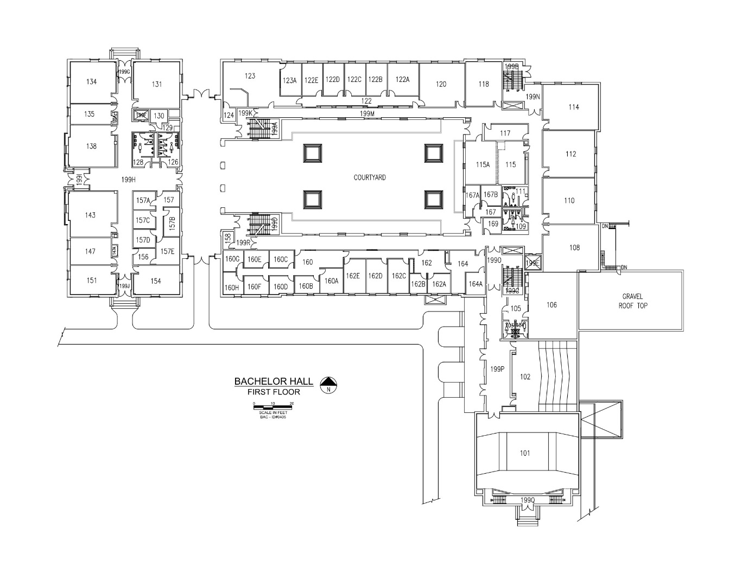

|  |
| --- |
| Save this Date!  2018 Fall Ohio Section MAA Meeting  Malone University  October 26 – October 27 |